Poetry
Write a poem based on the Ancient Egyptians!
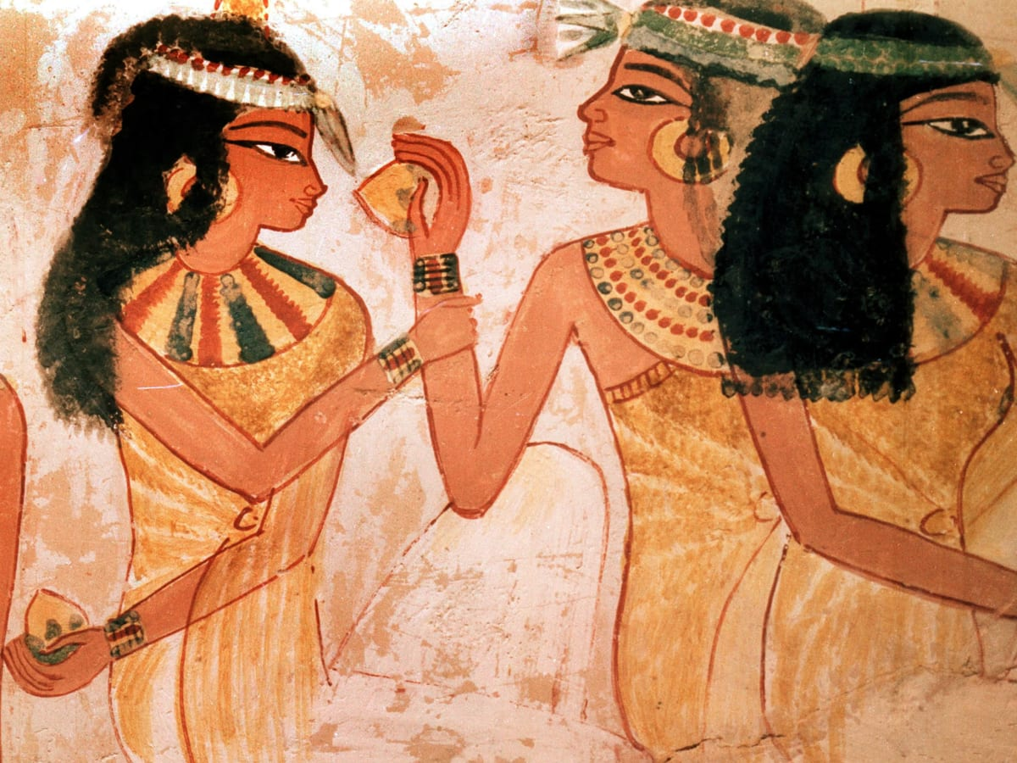

Write like an Egyptian!
The Egyptians didn’t write like we do today. They wrote in something called Hieroglyphs!
Have a go at writing like the Egyptians.
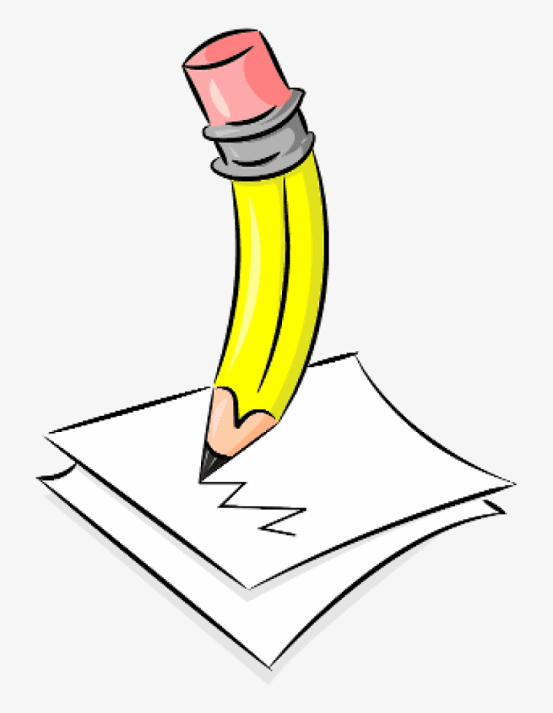

Imagine …
Imagine you have travelled back in time to the time of the Ancient Egyptians!
Write a diary entry about what you might see or do. How might you be feeling?
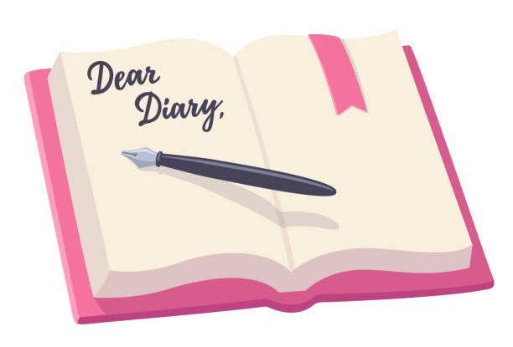
Key Vocabulary
Create your very own wordsearch or puzzle to help you remember all our key words!
Pharaoh, tombs, pyramid, hieroglyphs, scribe, sarcophagus, mummy, papyrus, death mask, canopic jar.
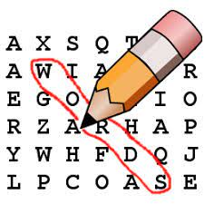

Build a pyramid
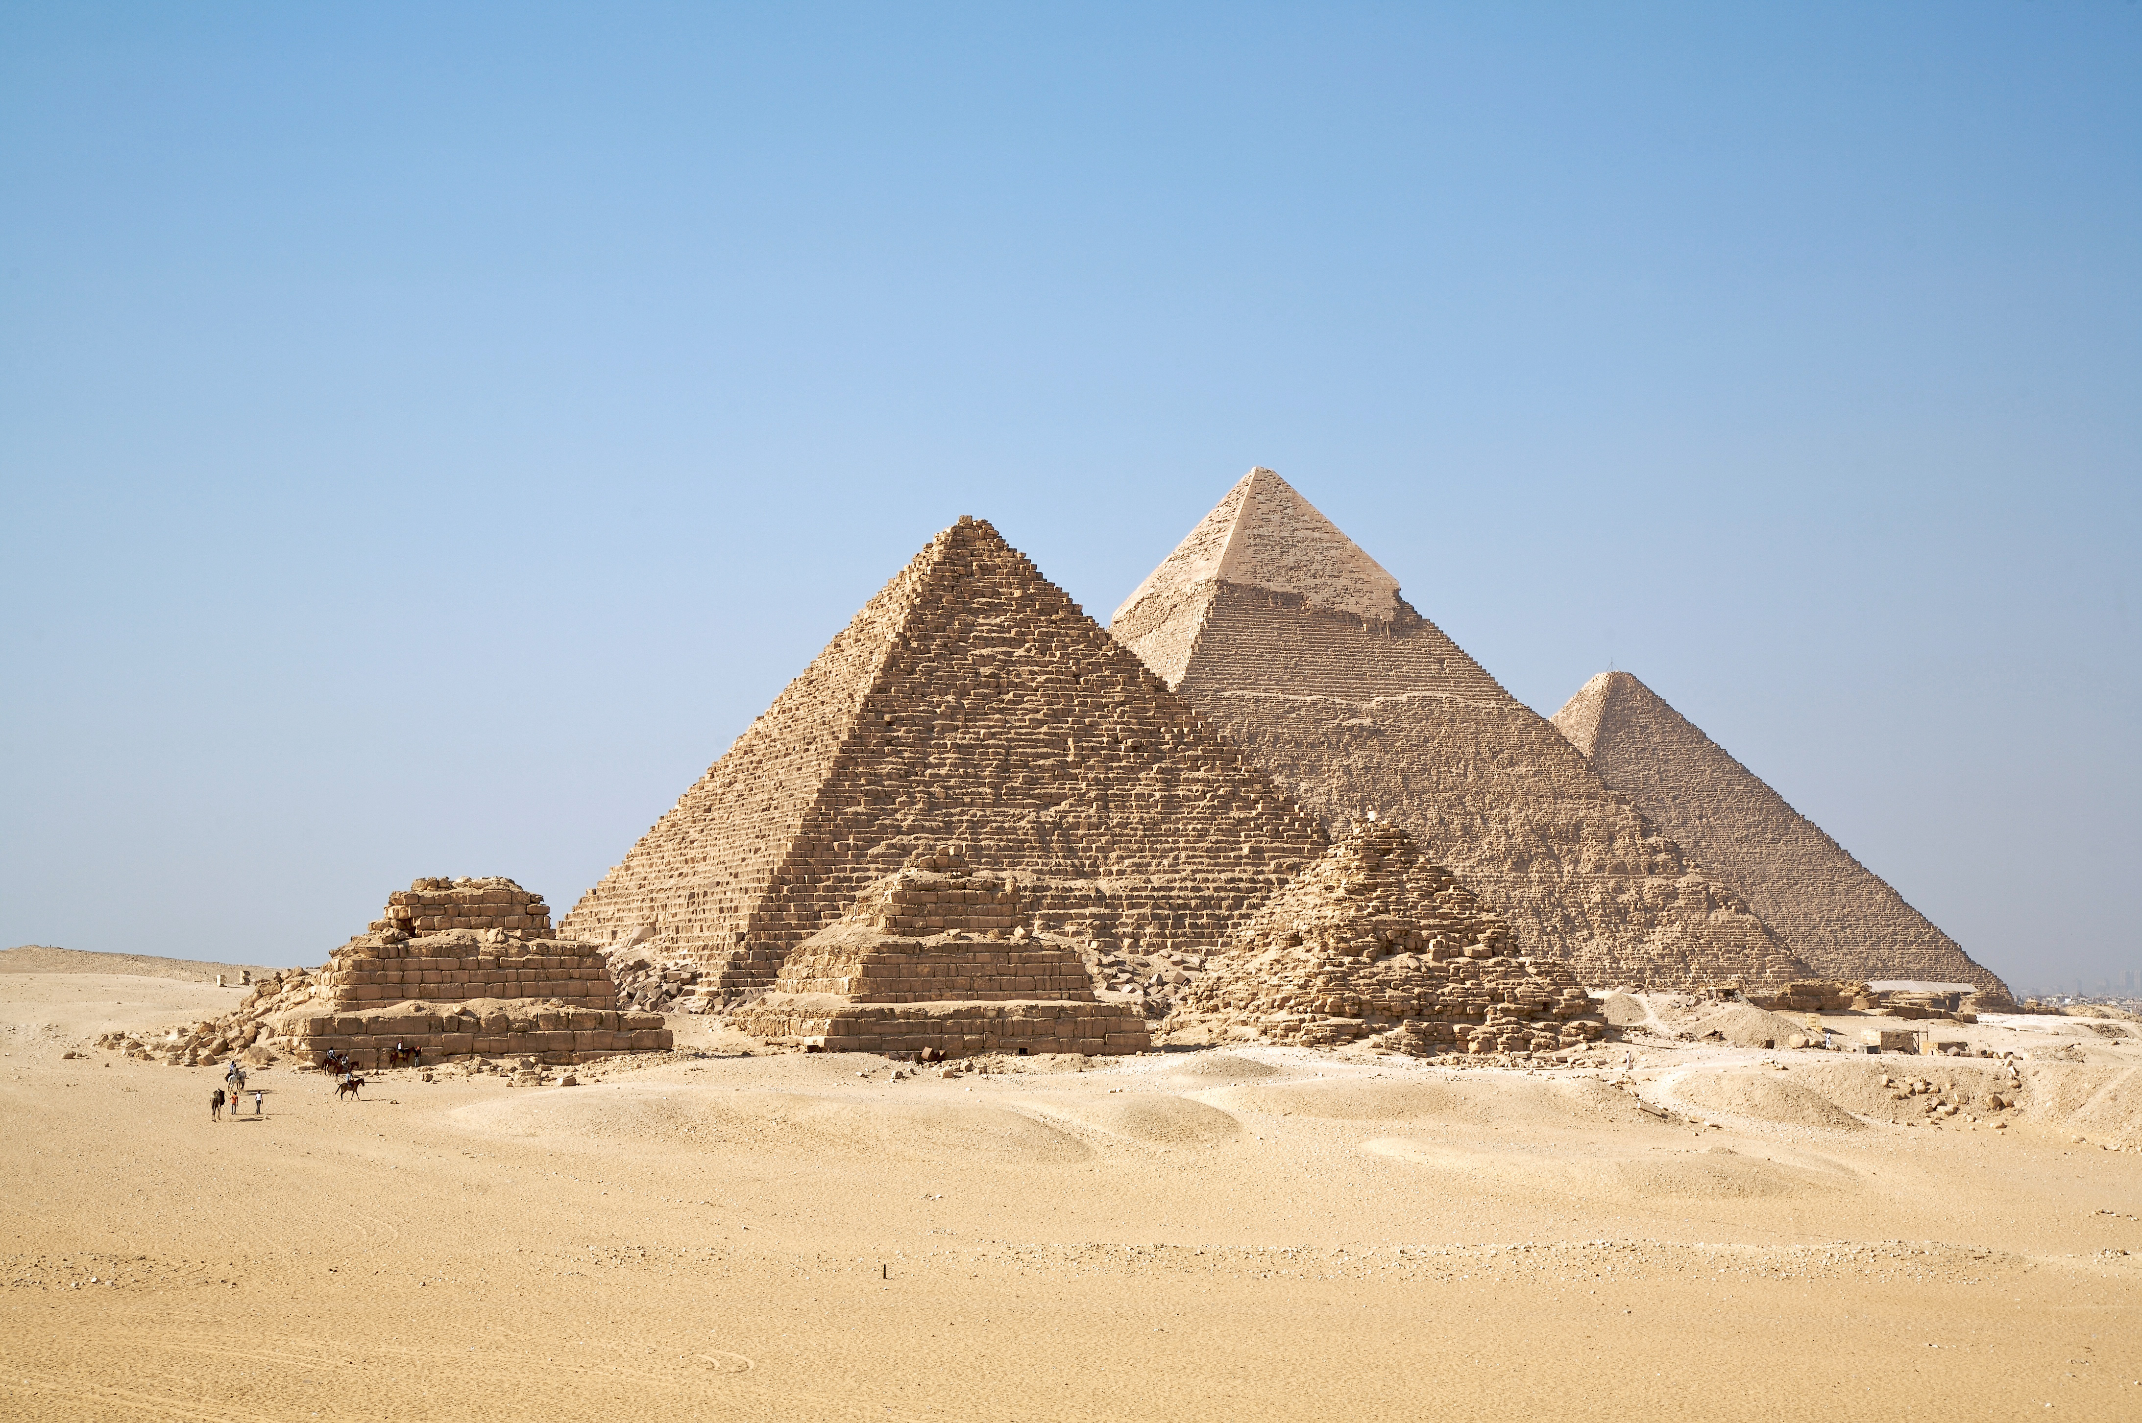
Have a go at making your very own pyramid. Get creative and have a go!

Topic Map
Here are a few activities that link to what we will be learning in class this term. These activities are not compulsory but are extras should you wish to do them.
This term our topic is: Ancient Egypt

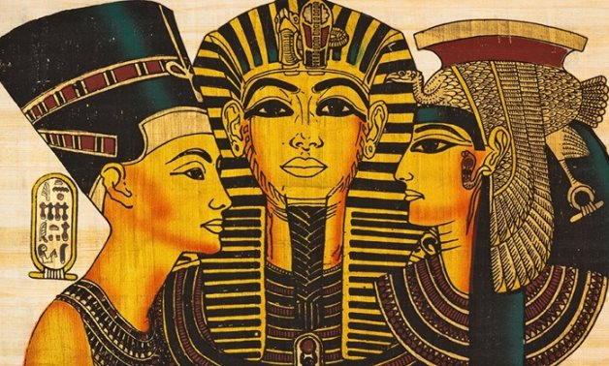
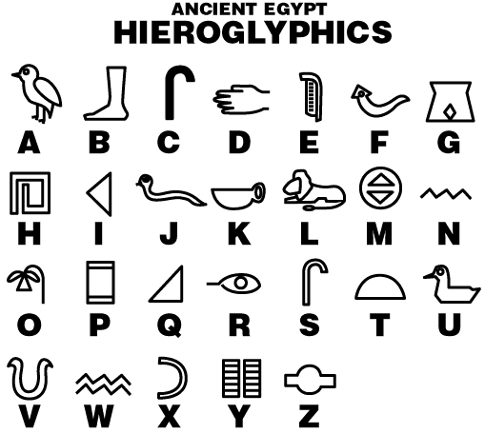

Art
Create a piece of artwork based on the Egyptians. You could draw, paint, collage …
