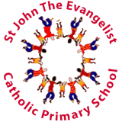
Typography and Maps

Art
Geography
Disciplines:
Typography, Collage, Drawing, Sketchbooks
Key Concepts
- When designers work with fonts and layout it is called Typography.
- We can use the way words look to help us communicate ideas and emotions.
- We can create our own typography and combine it with other visual elements to make artwork about chosen themes.
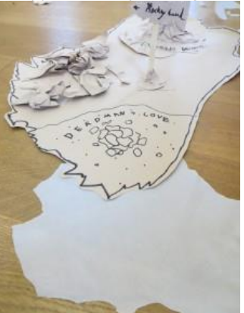
Key Vocabulary
Typography | Working with fonts and layout
legible | clear enough to read.
font | text characters in a specific style and size.
Convey messages | communicate messages to someone directly or indirectly through your words or actions.
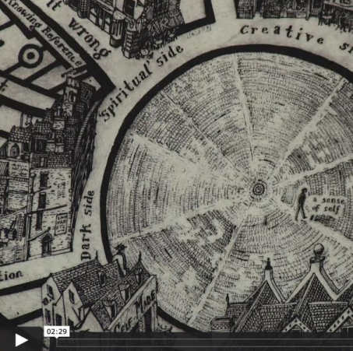
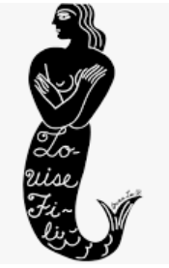
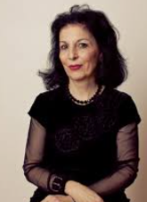
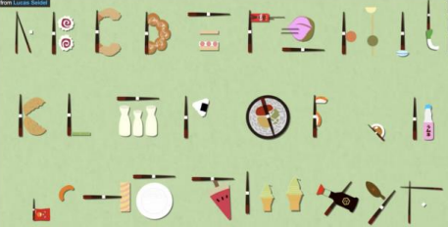
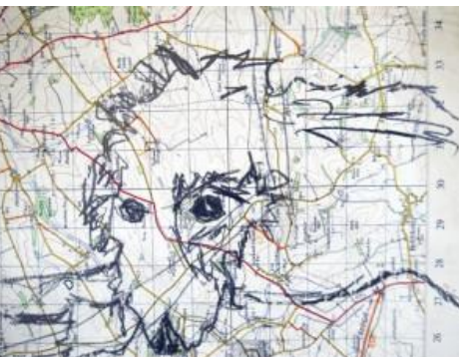
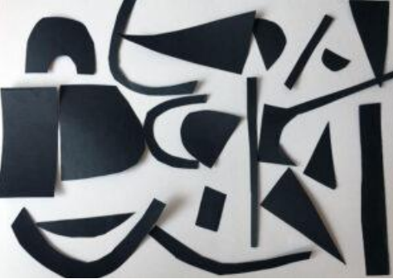
Key Artists

Louise Fili

