Vocabulary
Air/ water resistance | Air/water resistance describes the friction between an object in air or water.
Upthrust | Is any force that is causing something to be pushed upwards.
Gravity | The force that attracts objects towards one another, especially the force that makes things fall to the ground.
Springs | Something’s ability to return to its usual shape after it has been pressed.
Lever | A bar or handle that moves around a fixed point, so that one end of it can be pushed or pulled in order to control the operation of a machine or move a heavy or stiff object.
Fulcrum | The point at which a bar, or something that is balancing, is supported or balances
Pulley | A piece of equipment for moving heavy objects up or down, consisting of a small wheel over which a rope or chain attached to the object can be easily raised or lowered.
Gear | A device consisting of connecting sets of wheels with teeth (points) around the edge, that controls how much power from an engine goes to the moving parts of a machine.
Streamlined-Drag | Designed or arranged in a way that makes movement easier through air or water.
Mechanism/ machine | A part of a machine or set of parts that work together.

How do forces affect our lives?
Forces
Science
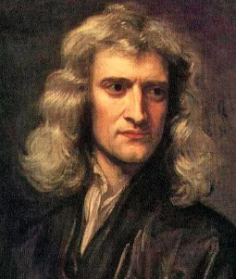
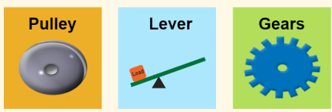
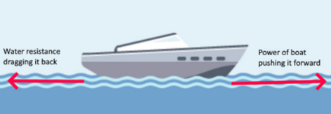
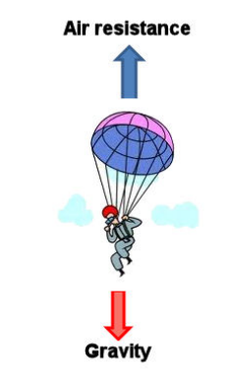
Sequence and Key Knowledge
- A force is a push or a pull. They can make things move, change their shape, or change speed.
- Gravity is an invisible that pulls objects down to the Earth. Without gravity everything on Earth would fly off into space.
- Friction happens when objects move through water or air. Air resistance is a type of friction between air and another material. Water resistance is a type of friction between water and another material.
- Levers, pulleys and gears are simple machines that make work easier.
- Levers are important parts in many tools e.g. hammers, bike pedals, tweezers. They help us to lift, move, break, squeeze objects and cut things.
- Pulleys are made by looping a rope over one or more wheels. The pulley changes the amount of force needed to lift an object e.g. lifts, cranes, hoisting a flag and curtain blinds.
- Gears are wheels with teeth that slot together. When one gear is turned the other one turns as well. Smaller wheels turn more quickly, with less force while the bigger one turns more slowly with more force.

Famous Scientist
Isaac Newton
Mathematician & Physicist
who developed theories about gravity.

