St John the Evangelist Catholic Primary School
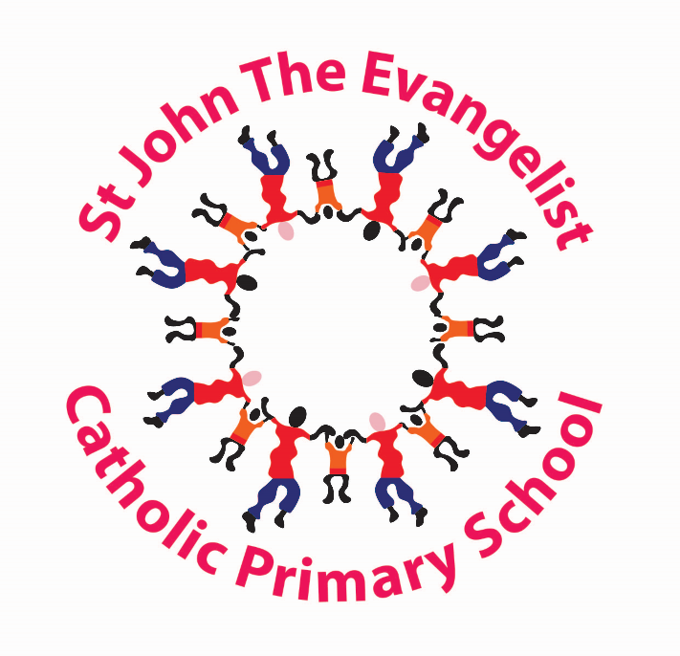

Uniform Policy
2026 – 2027

‘We Follow in the Footsteps of Jesus’
School Uniform

We do ask parents to ensure that their children come to school clean, smart and wearing our school uniform. We feel that the wearing of our school uniform helps all pupils take pride in their appearance creates a sense of community. Our school uniform can be purchased from Embroidery In House, Bradford.

Our school uniform consists of the following:
Boys  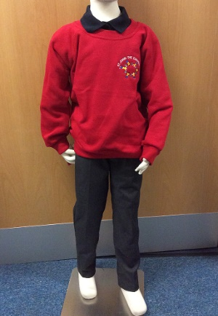 | Girls  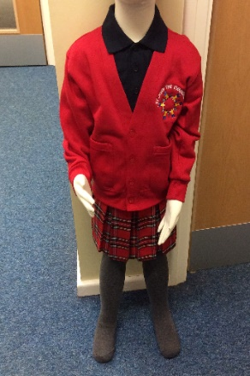
Navy polo shirt (logo optional)  Grey trousers/shorts  Red Sweatshirt (must have logo)  Black outdoor shoes (No Trainers) | Navy polo shirt (logo optional)  Red Tartan or Grey skirt  Grey Pinafore  Plain Red or Grey Tights  Grey trousers  Red Sweatshirt/Cardigan (must with logo)  Blue or Red Gingham Dress (summer)  Black outdoor shoes (No Trainers)
P.E. kit for all children consists of:
Navy shorts & Red t- shirt, tracksuit for outdoors and outdoor trainers (year round) – PE kits should be worn on your child’s designated PE days.

PE kit does NOT have to have the school logo on. This can be purchased at your local supermarket or Embroidery In House.

Please, please, please:
Clearly label ALL items of clothing and shoes with your child’s name. School would stress the need to mark your child’s name in each article of clothing. Red sweatshirts are identical – how does your child know which is theirs if it is not clearly marked?
Tie shoulder length hair back – this applies to both girls and boys.
Keep mobile phones at home. Only Year 5 & Year 6 children who walk home are allowed to bring them into school and are handed into the office each day.
Send your child in with their P.E. kit in a pump bag which will be kept on your child’s peg. Pump bags MUST not be big bulky rucksack, only a small bag please due to limited space.
Send your child’s book bag into school each day. Replacement book bags can be purchased from our uniform providers-Embroidery in House Shop in Clayton.
Please DO NOT:
Send your child into school in ‘designer’ items of clothing.
Send your child into school with extreme hairstyles which have been dyed or coloured or that require styling products. Hair with tramlines and designs shaved into the head are NOT part of our school uniform.
Send your child into school with cosmetic accessories i.e. tooth gems.
Allow your child to bring any toys or games into school unless requested to do so by the class teacher. (Please note neither the school nor the LEA can accept responsibility for any personal belongings which are lost or damaged at school. All personal clothing and belongings should be clearly marked with the owner’s name).
Please DO NOT:
Send your child into school wearing nail varnish or make-up. All nail varnish and make-up must be removed before coming into school.

Allow your child to wear any items of jewellery – earrings, if worn, should be small studs as hoops can very easily cause damage and injury. Small watches can be worn but necklaces and bracelets must be left at home.

Send your children in shoes which are brightly coloured or with a designer label (no trainers).

Send your child into school with mobile phones, if they are found in school they will be locked in the office until home time, when they will be returned to your child.

Policy Start: December 2025
Next review due: December 2027

